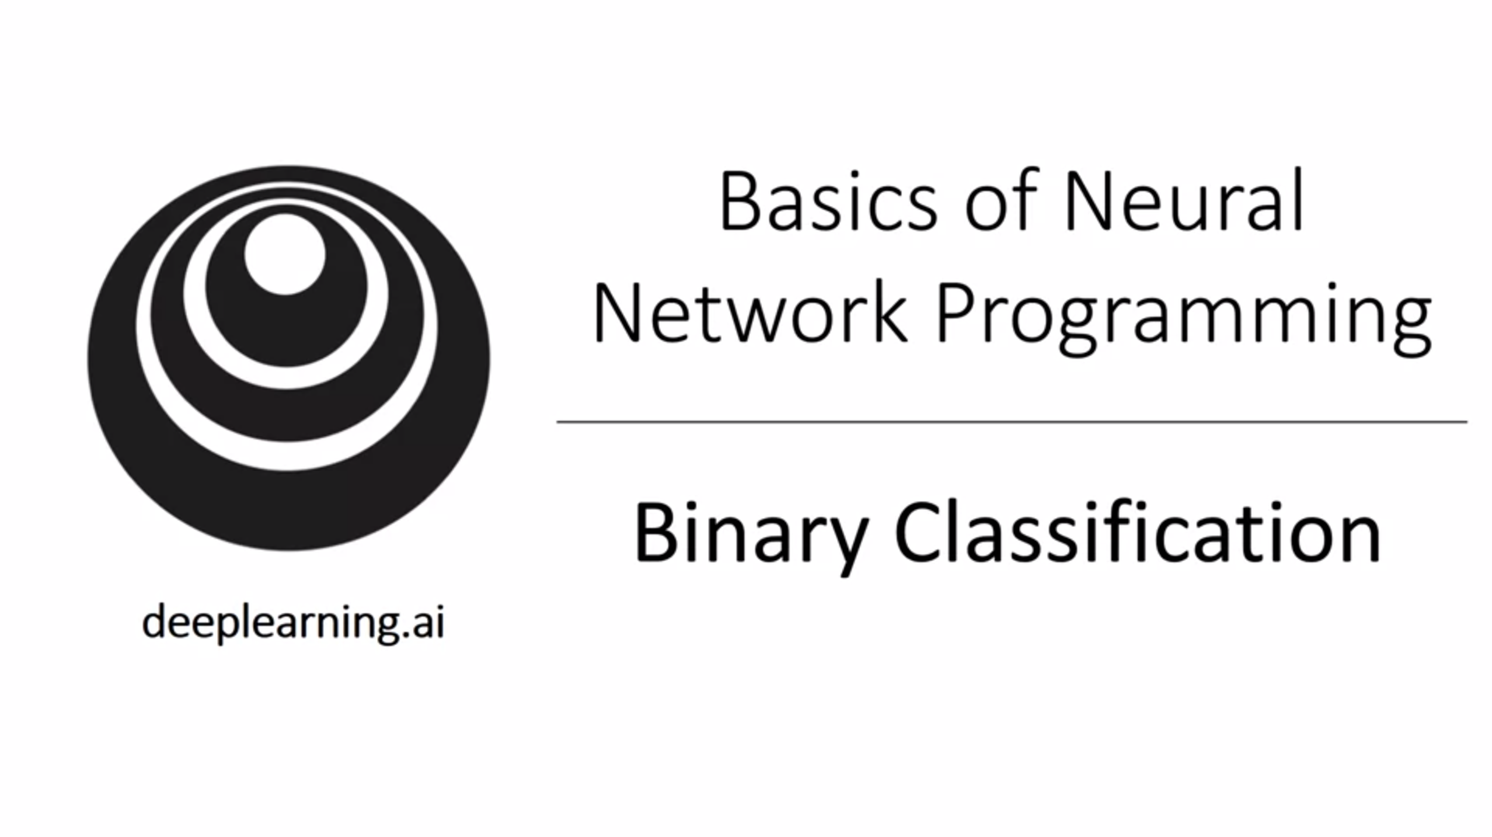Vectorization instead of for loop is essential! Forward pass and backward pass: we will learn intuition on how these things work and why a NN can be organized that way.

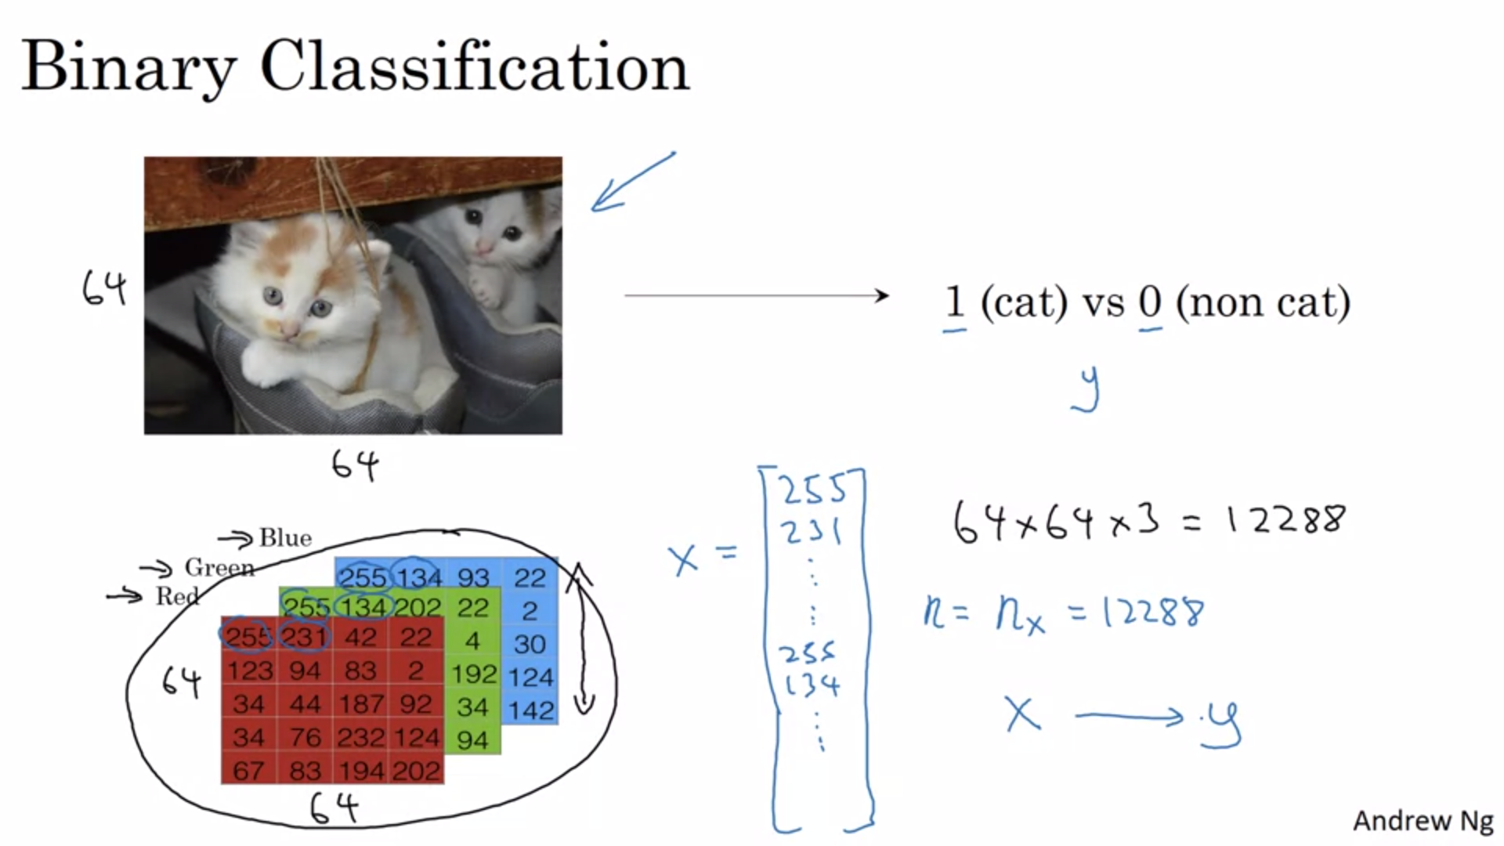

Logistic regression Is an algorithm for binary classification. Image is represented by pixel intensity values over 3 color channels (RGB). They are unrolled into a feature vector. First list all the red pixels, then the green and then the blue. 64x64 image will result in 64x64x3 = 12288 vector.

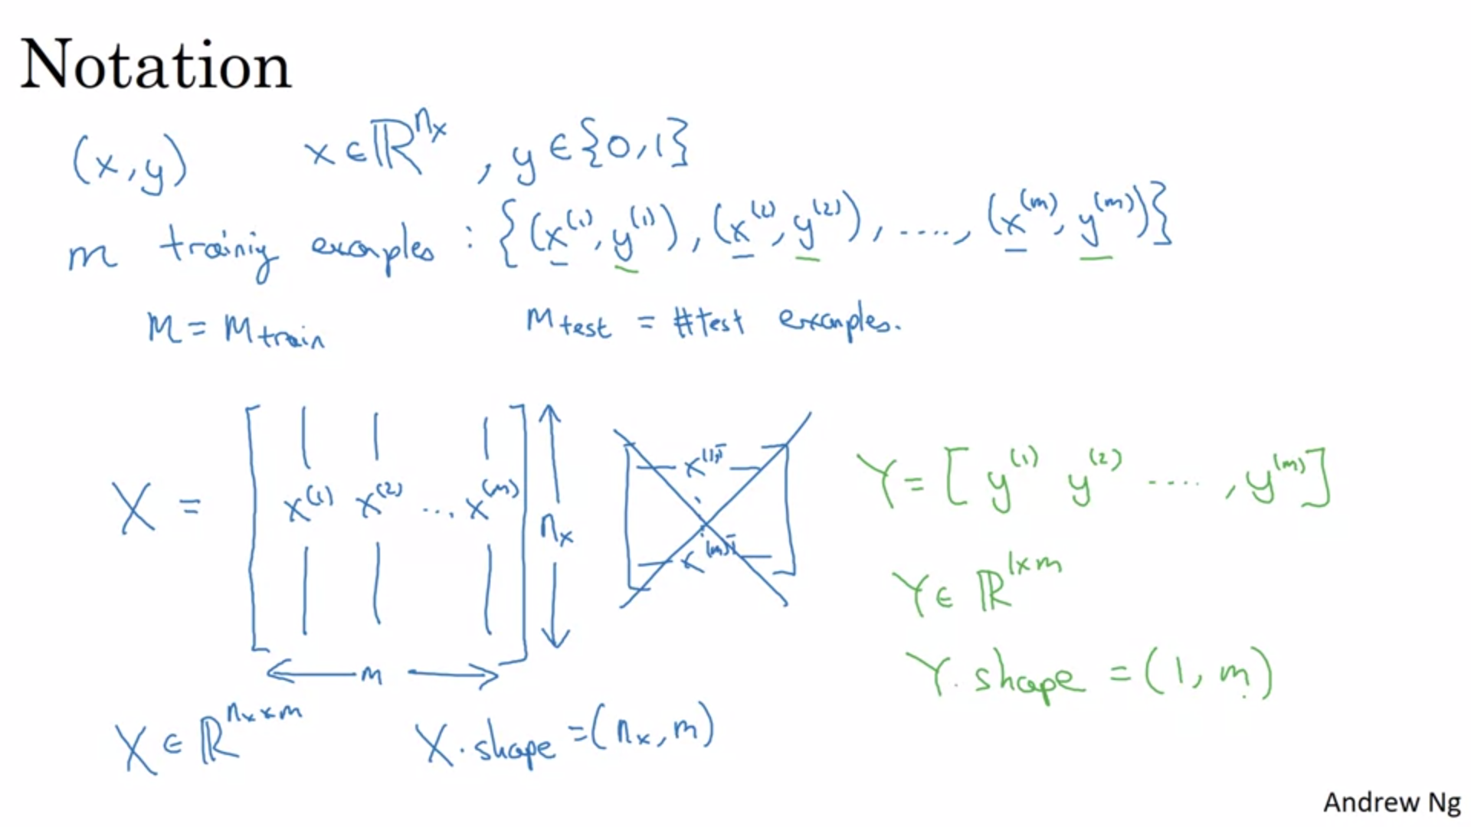

X is a compact representation with training examples stacked in columns.

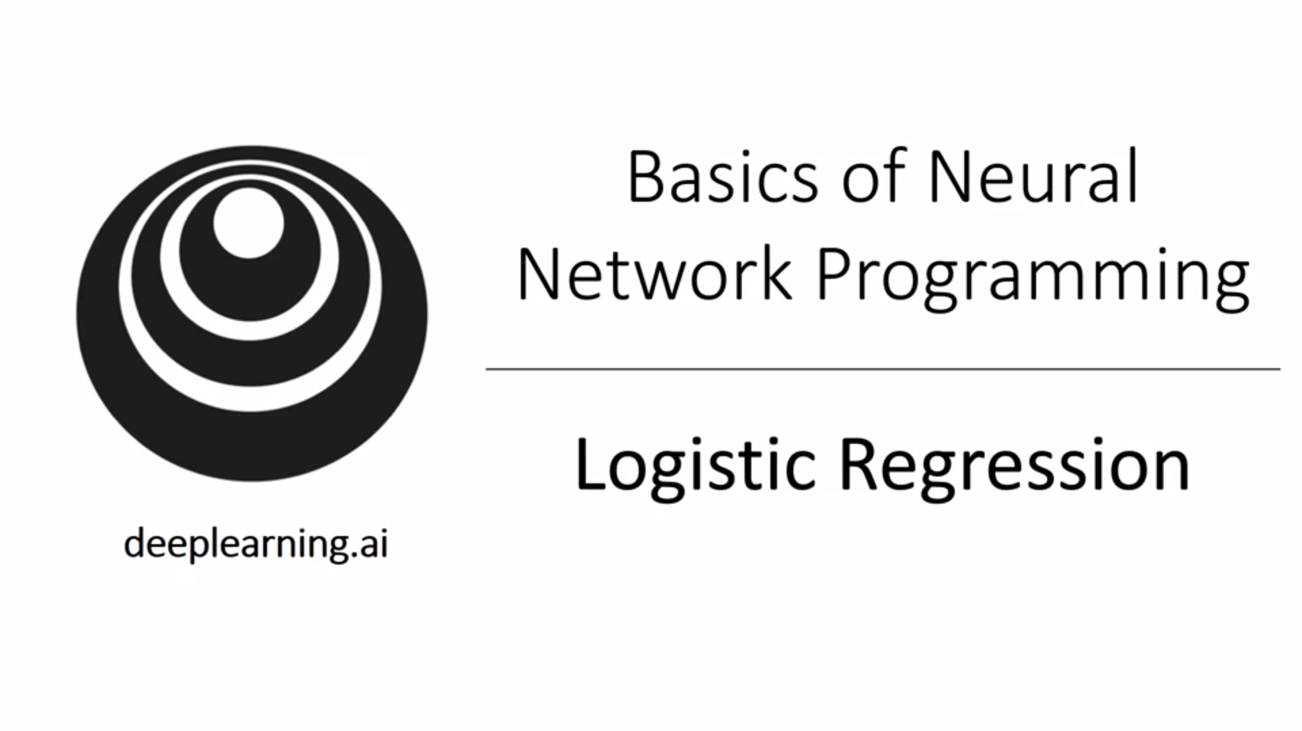

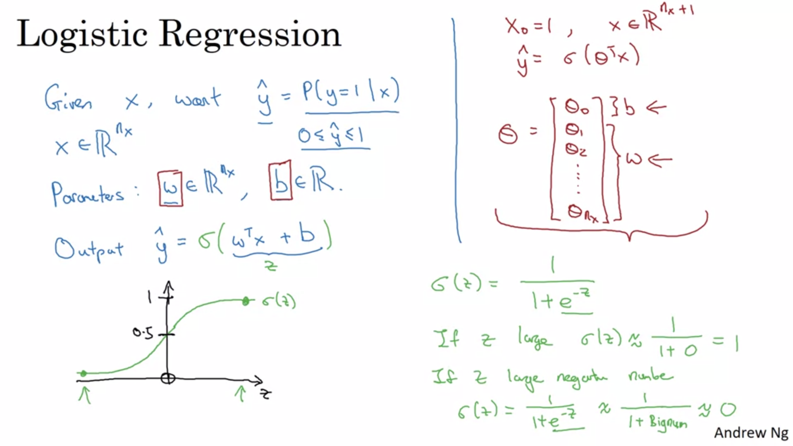

Linear function would not work because we want y_hat to be the chance that y is equal to 1. Y_hat has therefore to be between 0 and 1. When we program neural networks, we keep w and b separate instead of defining an extra feature for the b constant.

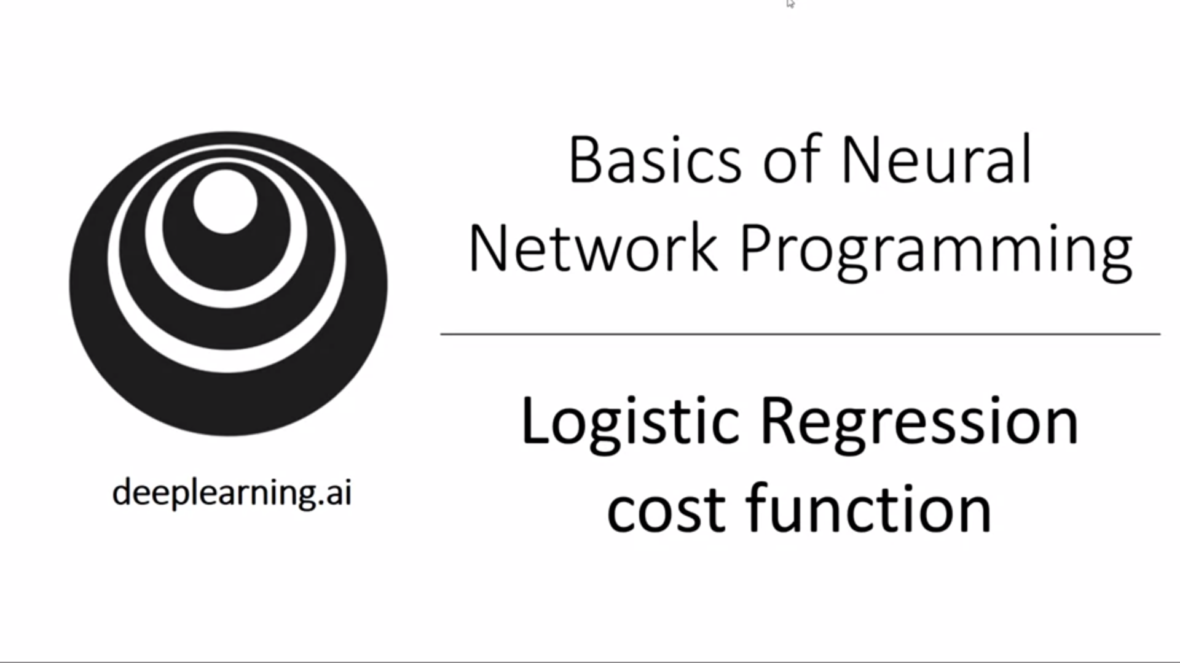

For each training example we use the superscript parentheses notation.

Squared error would be a possible cost function but it becomes non-convex for this optimization problem and, thus, gradient descent would not work well.

The loss function is important to measure how good our output y_hat is given a true label y. We want it to be as small as possible.

For the first case the loss function will try to push y_hat to 1, for the second case it will try to push it to 0.

Loss function is defined for a single training example. Cost function measures how well we are doing on the entire training set.

We want to pick w and b so as to minimize the cost function.

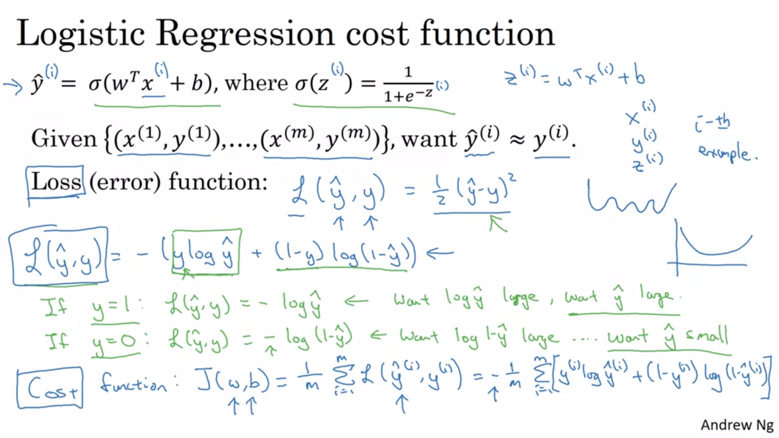

Logistic regression can be viewed as a very small neural network.

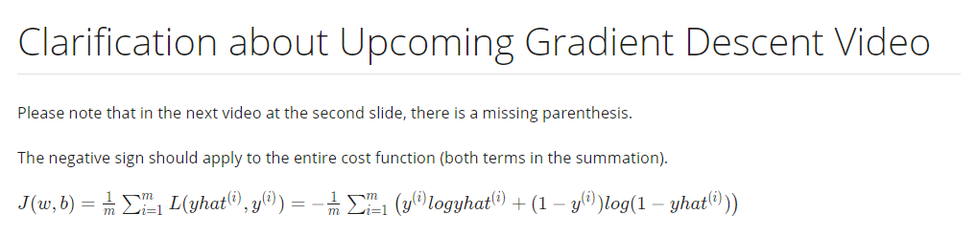

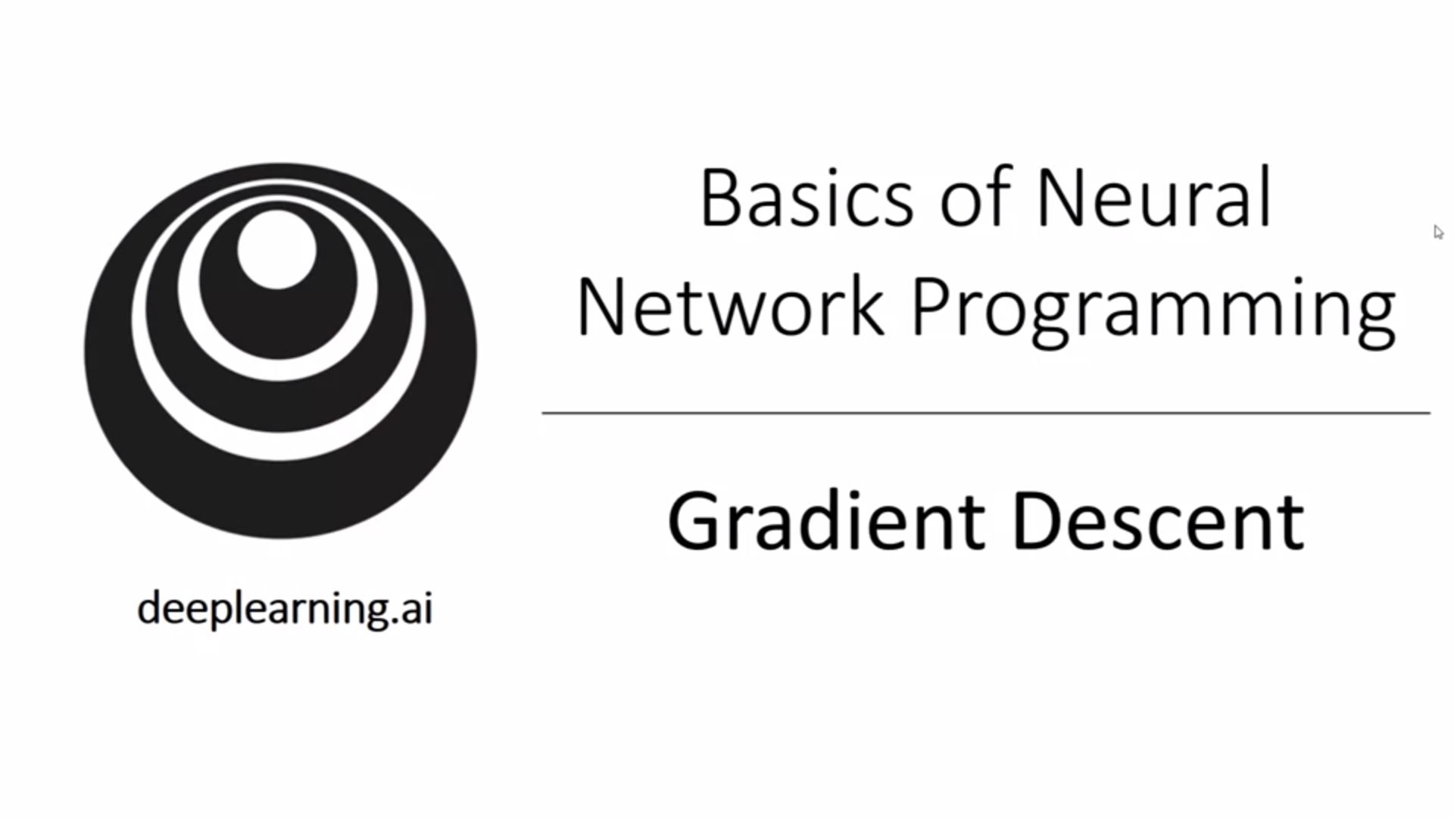

How to use gradient descent algorithm to learn w and b.

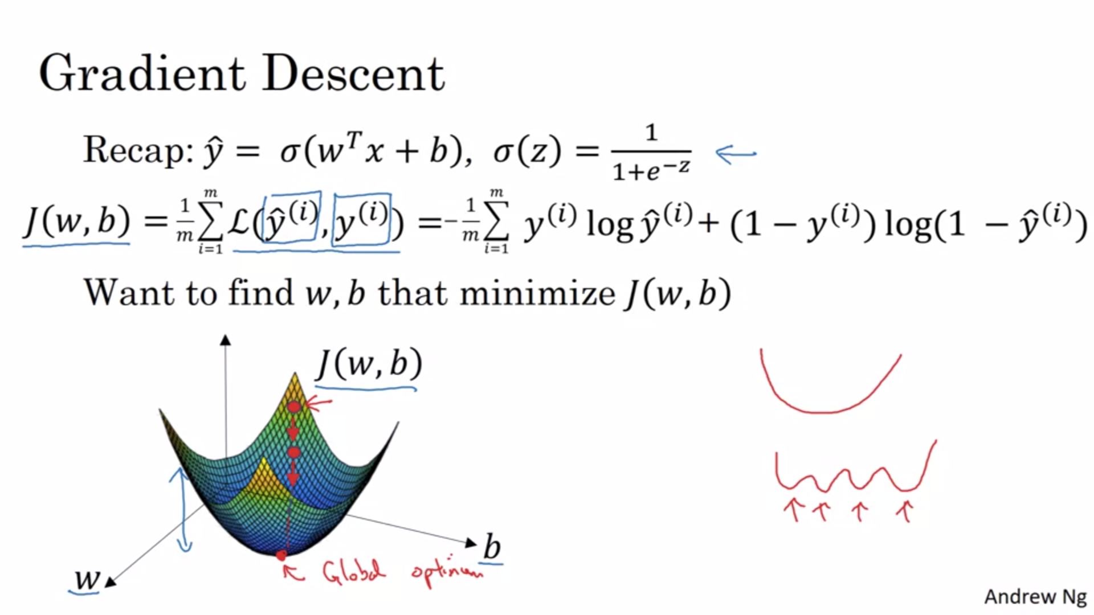

In reality w is much higher dimensional, just for illustration purposes 1d here.

The cost function as defined here is convex. This is one of the main reasons why we use this cost function for logistic regression.

For logistic regression we usually initialize the parameters to 0.No matter where you initialize you should get to roughly the same point.

Gradient descent takes a step downhill in the direction of steepest descent.

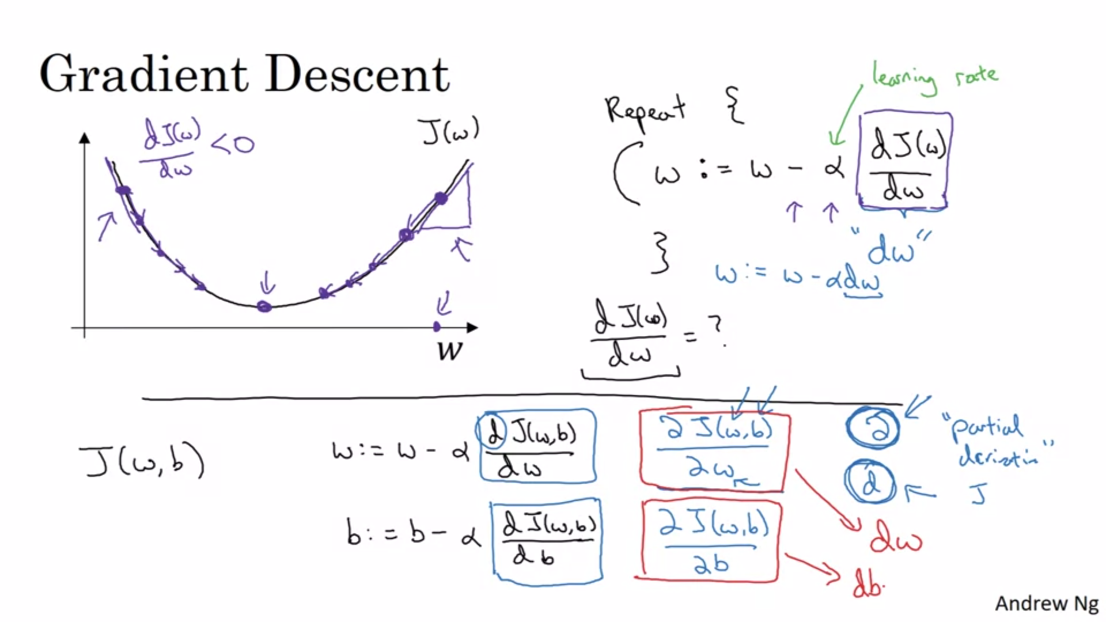

We will talk later about how to choose alpha.

The blue is the convention in code.

Slope is tangent of the triangle.

We will see more about derivatives and calculus later but we have to know for now that the particular gradient represents the slope of the function at the position of the parameter.

The parameters are updated according to the gradient descent update formula.

Notational difference between lowercase d and partial derivative sign (if J is a function of two or more variables).

Red is our convention in code.

You don’t really need deep understanding of calculus to make neural networks work effectively.

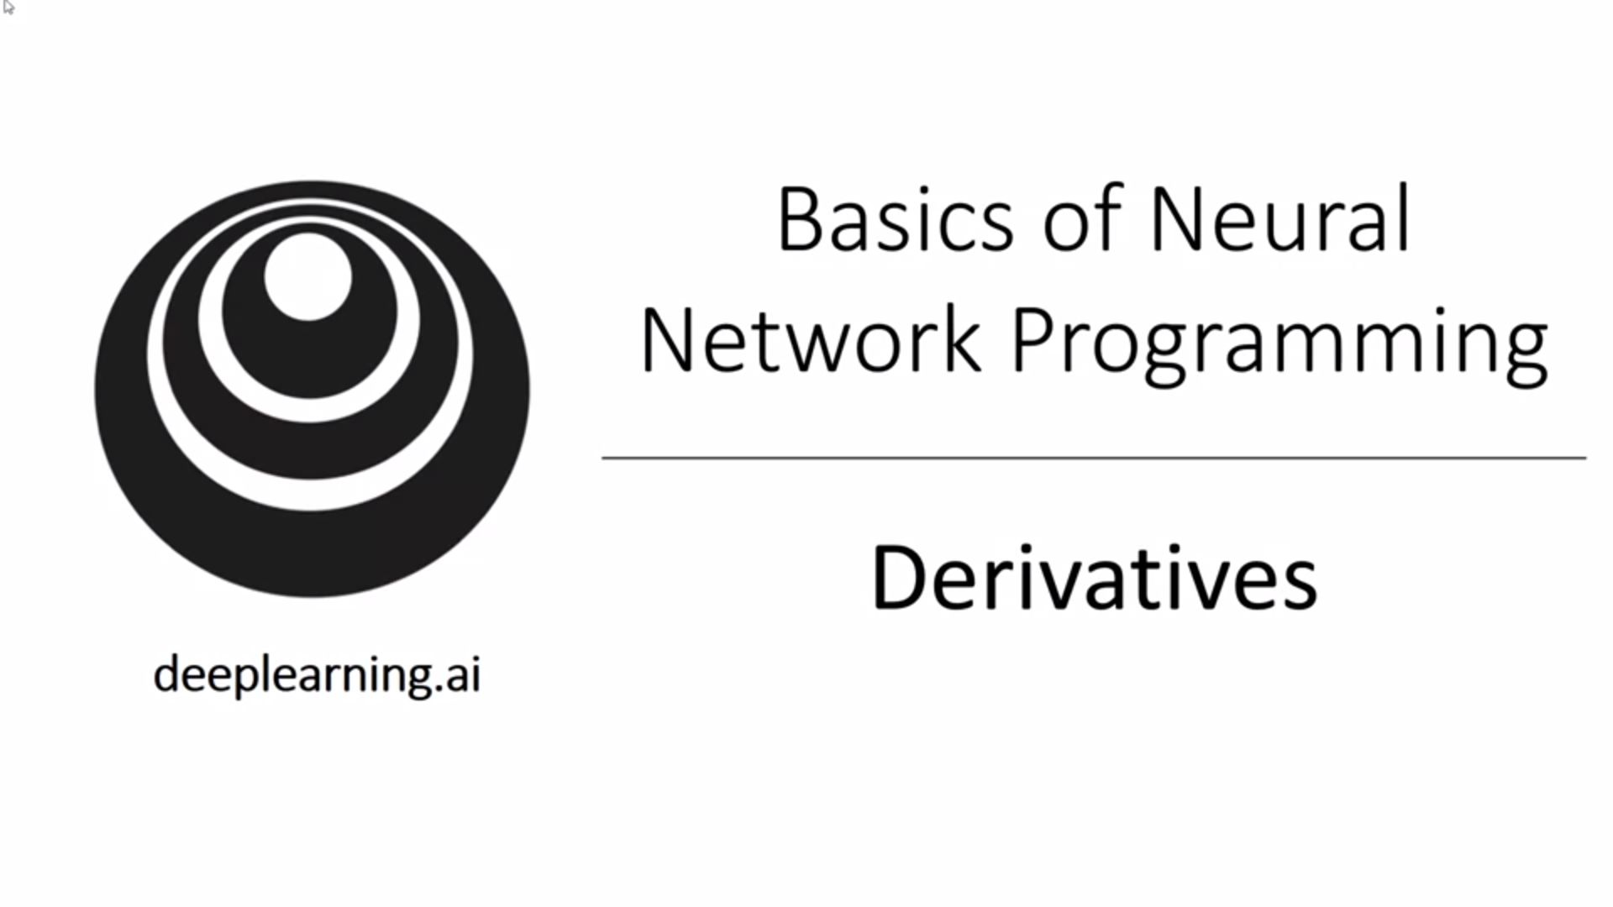

Everything that needs to be done with respect to calculus will be encapsulated during implementation (backward pass function).

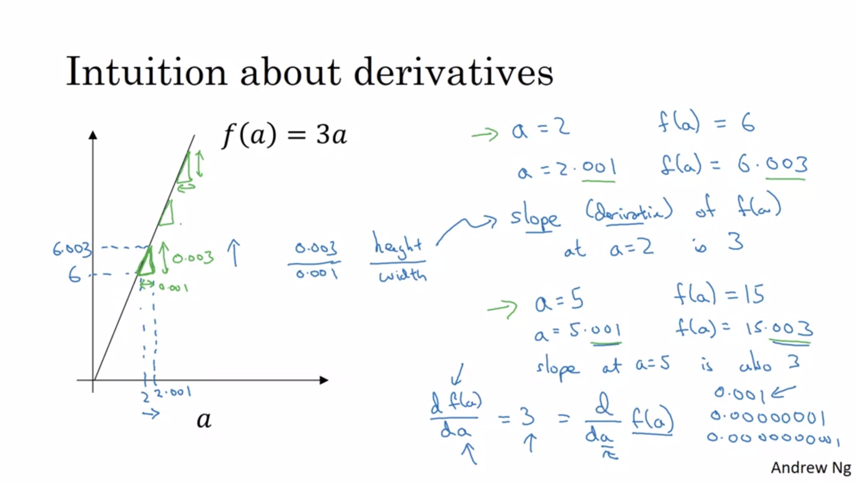

Intuition: If I give a tiny little nudge to the right, how will f(a) change? The formal mathematical definition of derivatives is even smaller than 0.000000.001 (it refers to an infinitesimal amount).

For this particular function the slope is constant.

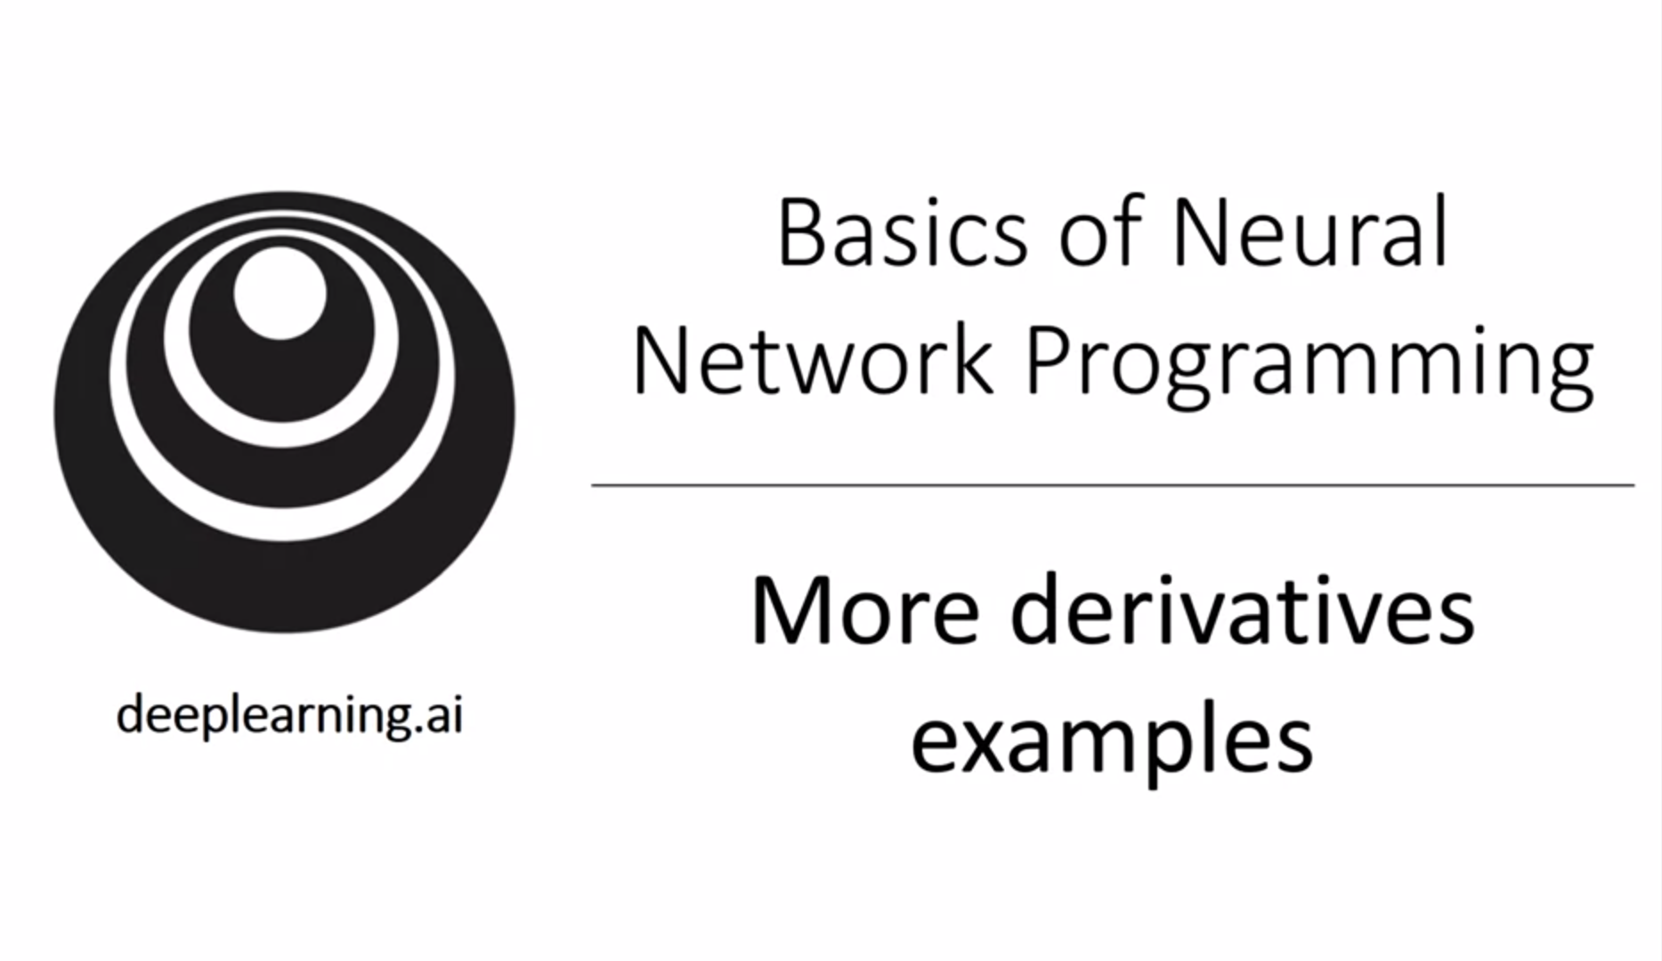

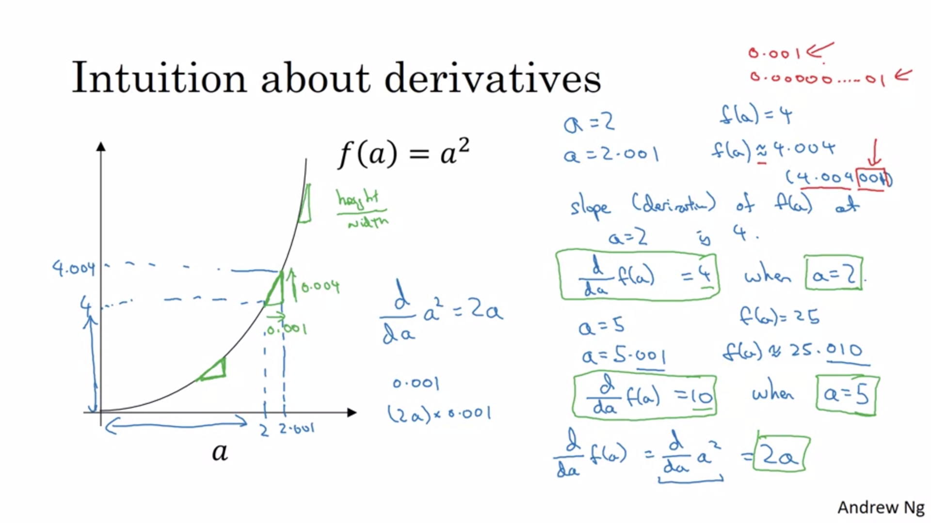

In this case the slope of the function is different depending on the value of a.

Extra error term marked in red is there because we have not used an infinitesimally small nudge.

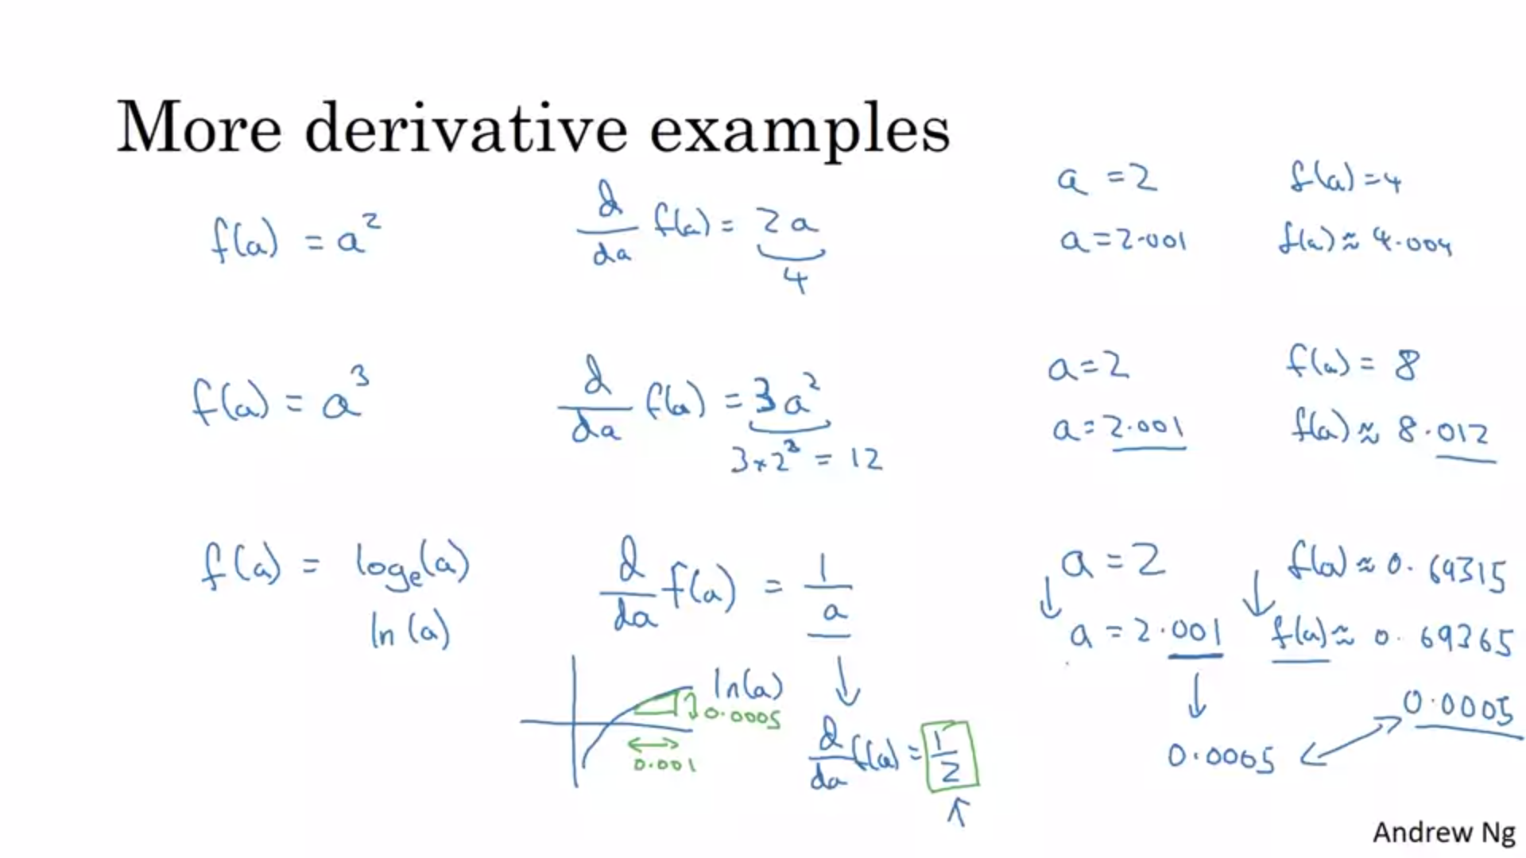

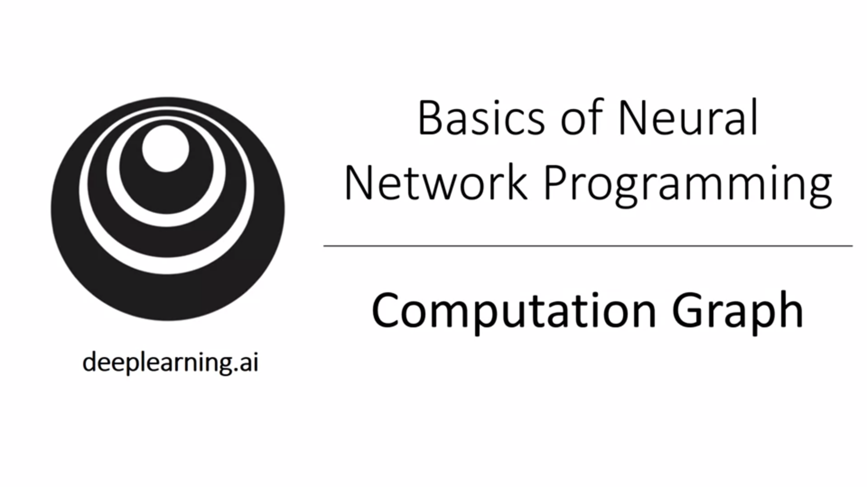

Computations of a neural network are organized into a forward pass in which we calculate the output of the neural network followed by a backward pass which we use to compute gradients/derivatives. The computation graph explains why it is organized this way.

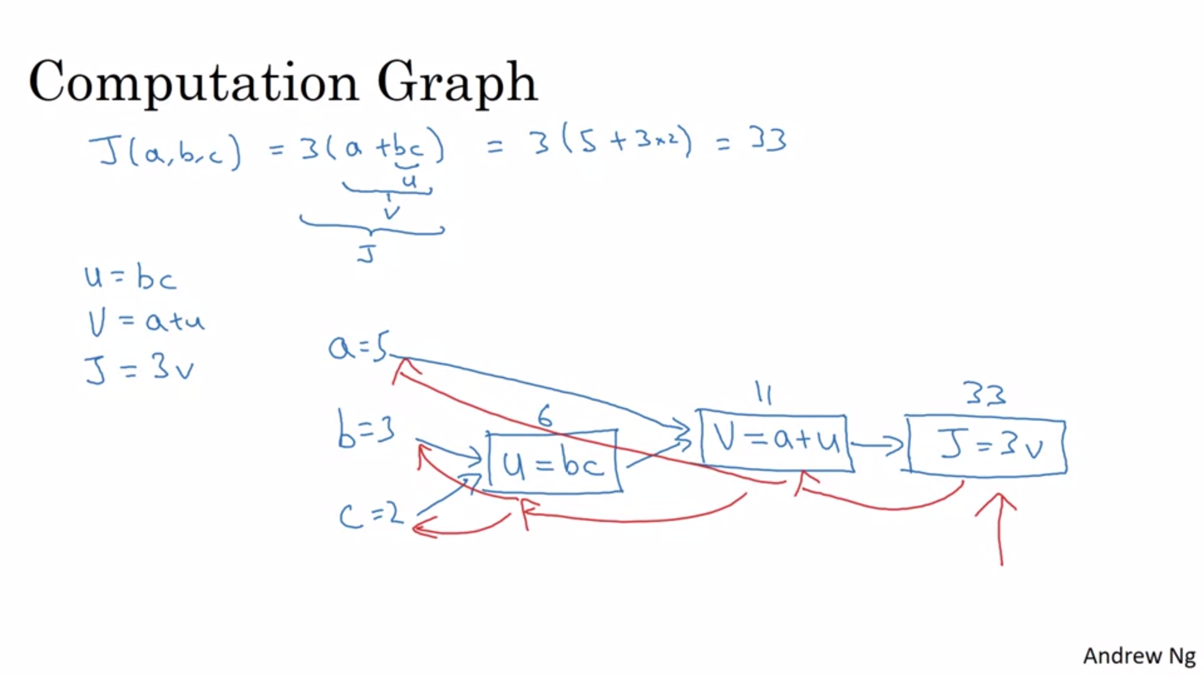

Here we use a simple function first to explain the concept of the computation graph.

Computation graph comes in handy when you have a function J that you want to optimize. J is the cost function that we try to minimize.

In order to calculate derivatives it is most natural to go backwards.

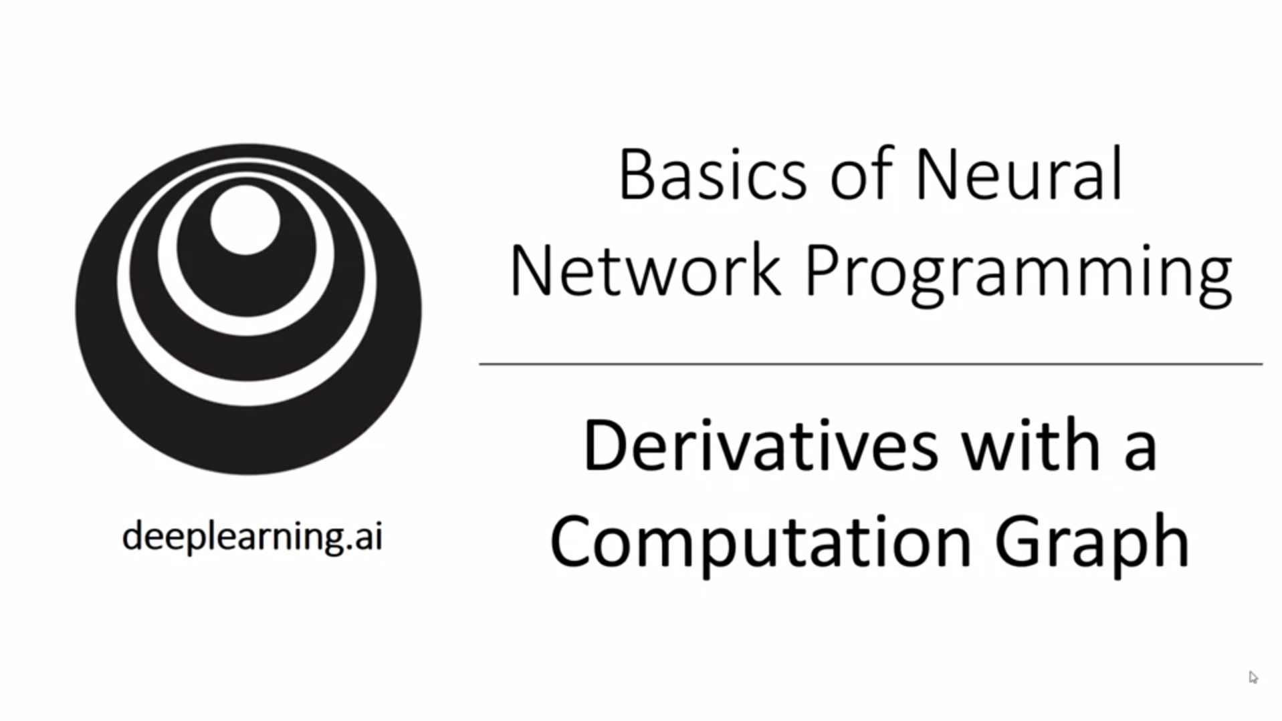

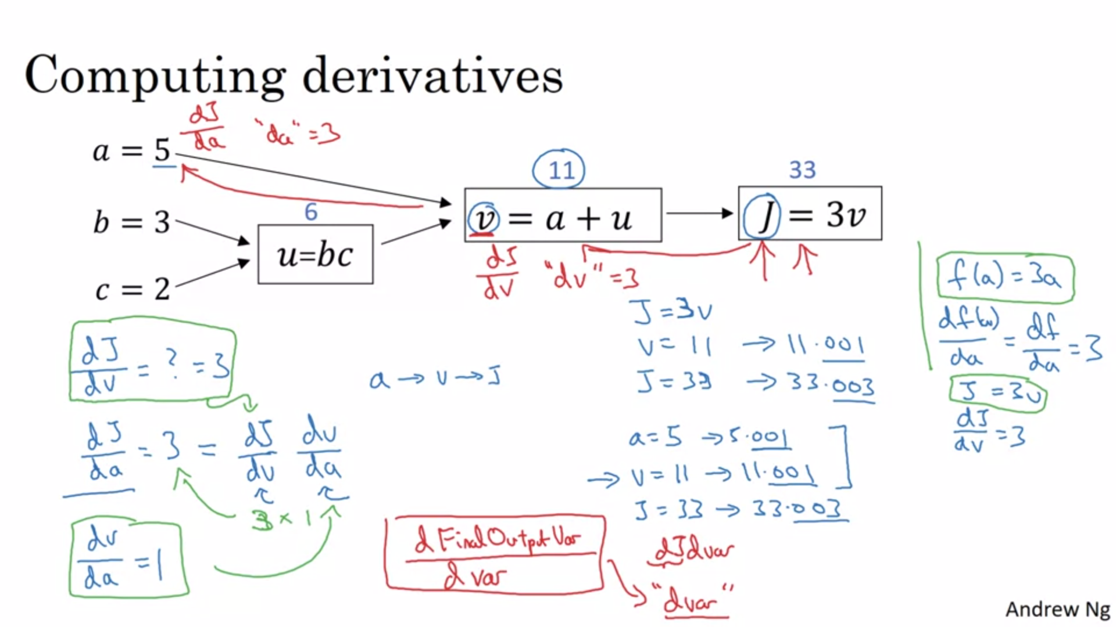

First we want to calculate the derivative of J with respect to v. f(a) is analogy to previous slides. Next we calculate the derivative of J with respect to a.

Chain rule.

Red indicates coding convention again.

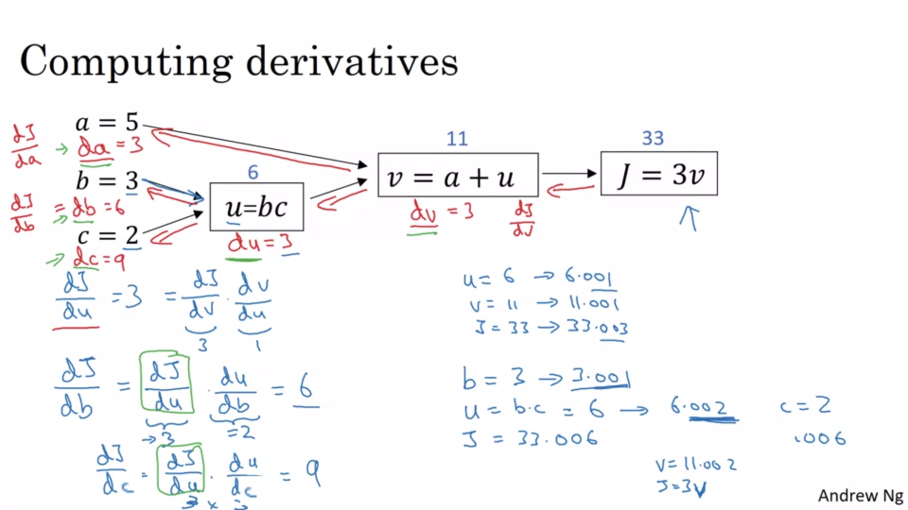

Next we calculate the derivative of J with respect to u. Next we calculate the derivative of J with respect to b using the chain rule of calculus.

Key takeaway: to compute derivatives the most efficient way is to do a right-to-left computation following the direction of the red arrows. Intermediate results become useful to compute the derivative of J with respect to initial input variables (marked in green box).

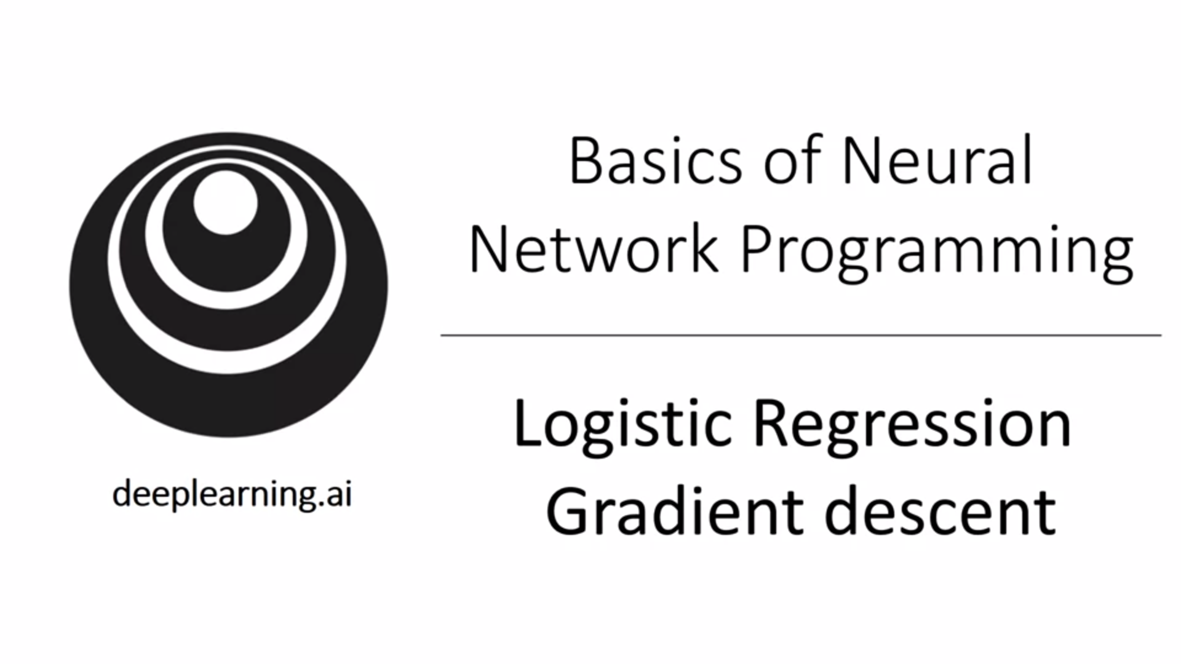

Now we build a computation graph for logistic regression. This is a little bit an overkill but a good opportunity to get familiar with the concept for more complex cases.

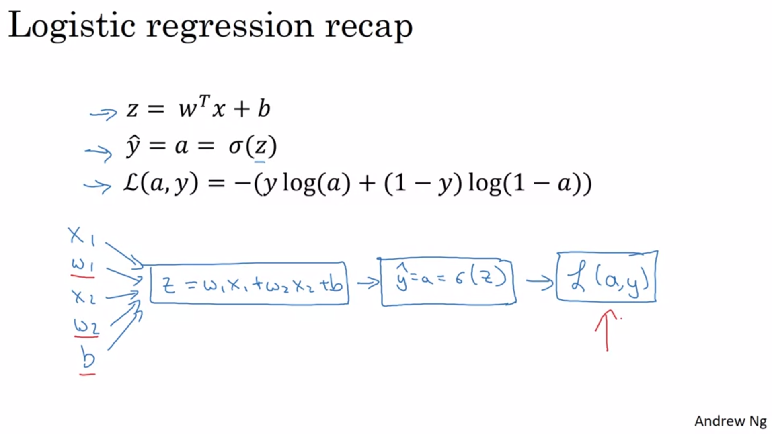

Remember: In logistic regression we want to modify w and b in order to reduce the loss function L.

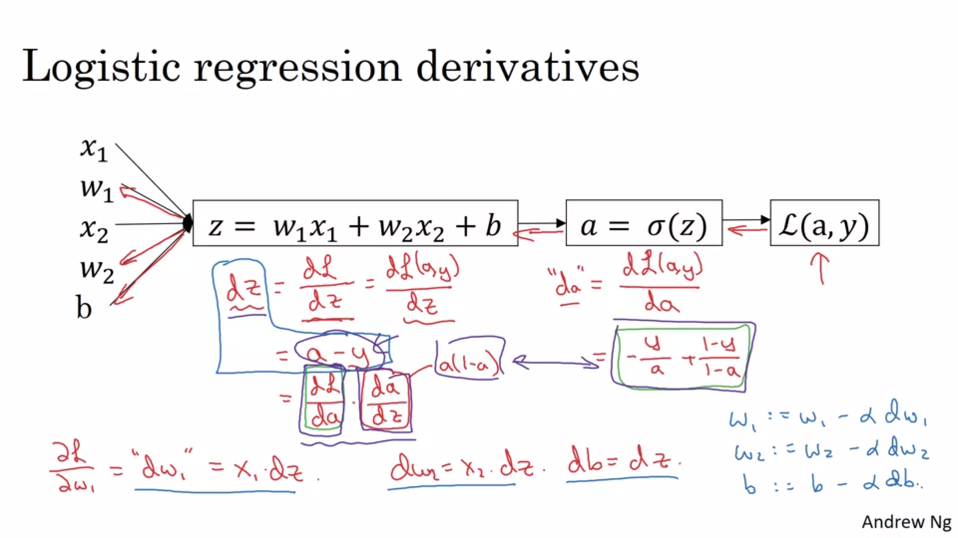

Y_hat is a here.

In this example we have seen gradient descent with respect to one training example. Next we will look at an entire training set with m training examples.

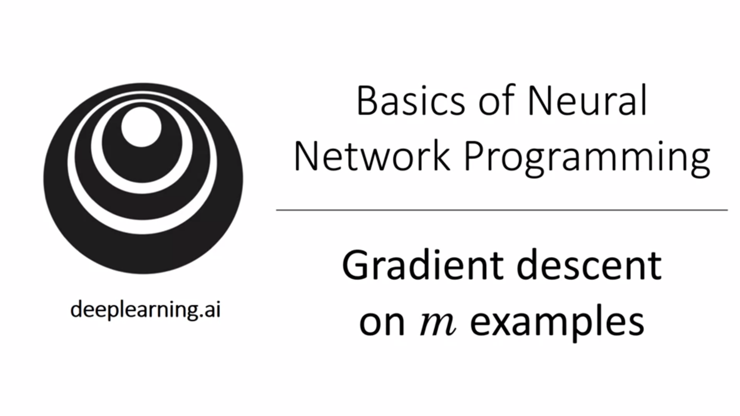

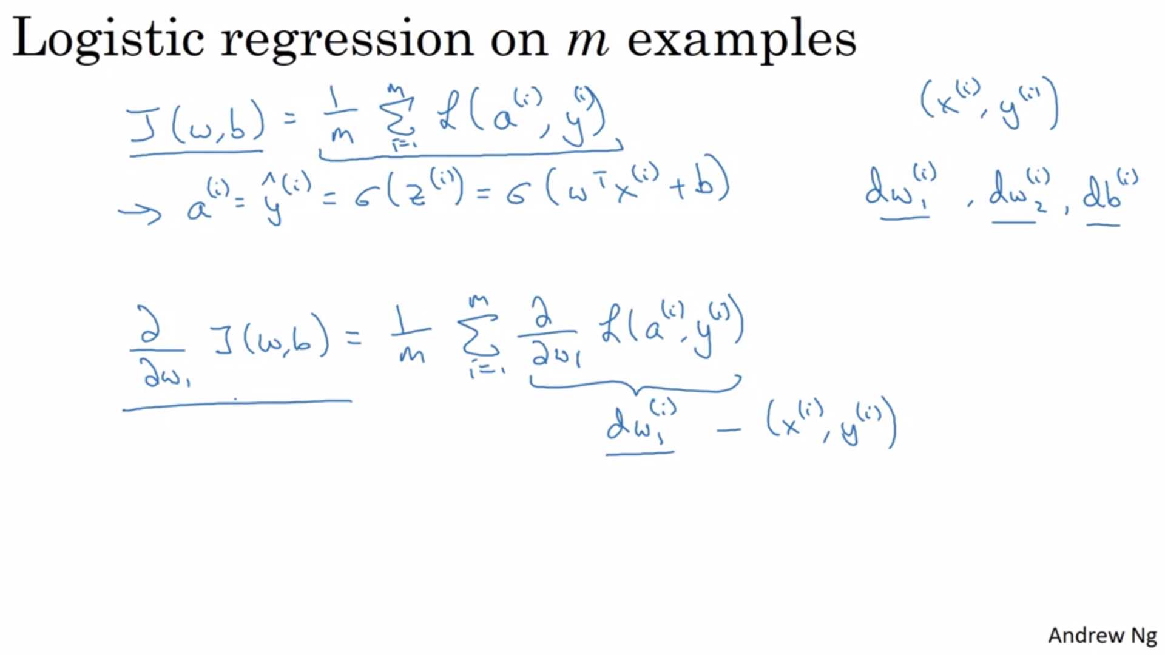

In the previous slide we showed how to compute the derivative given just one training example x_i and y_i. The overall gradient is retrieved by computing the individual gradients and averaging them.

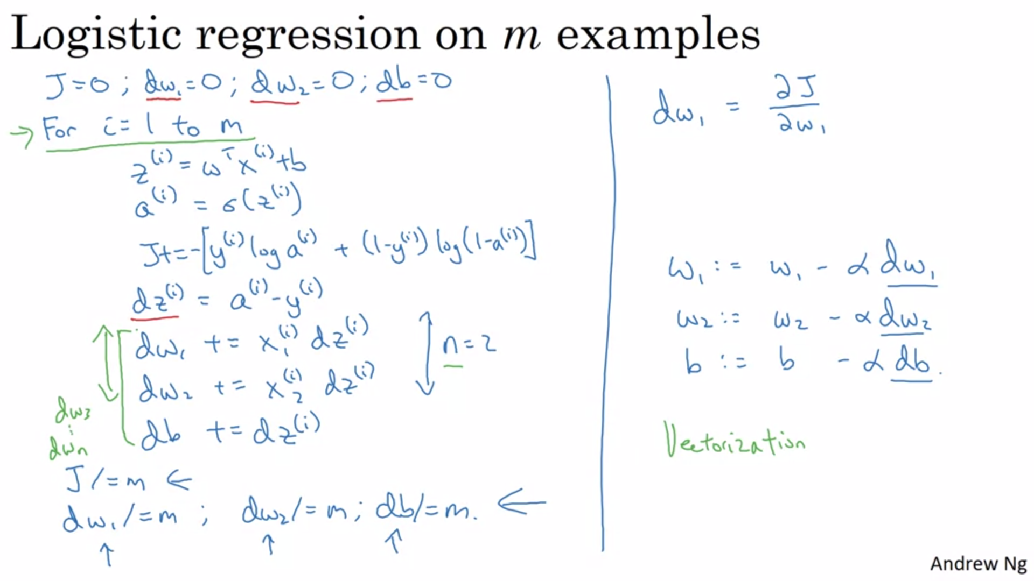

Initialize gradients with 0. Then loop over all training examples and do forward pass and compute loss function. Then do backward pass and compute individual gradients and add them to overall gradient. After the loop divide by m to compute averages. We are using dw and db as accumulators here. Then update with gradient descent -> everything on this slide just implements one step of gradient descent. So all of this has to repeated multiple times.

There are two weaknesses with this implementation: two for loops are needed… Explicit for loops in code make it very inefficient -> it is really important to use vectorization to avoid for loops in the era of deep learning (in the pre deep learning era vectorization was nice to have; now it is very important!)

